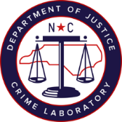
Request for CODIS Deletion/Upload of DNA Profile
Date: Click here to enter a date. | Agency File#: Click here to enter text.
Notifying Officer: Click here to enter text. | NCSCL Lab#: Click here to enter text.
Agency: Click here to enter text. | NSCSL Item#: Click here to enter text.

Deletion Request:
Profile matches individual not associated with a crime (consensual partner, witness, victim, etc) | ☐
Investigation has determined that no crime was committed | ☐
Profile is no longer eligible for entry | ☐
Other (explain): Click here to enter text. | ☐

Upload Request:
Investigation has determined that a crime was committed | ☐
Additional information has been provided that links item to a possible crime | ☐
Other (explain): Click here to enter text. | ☐

Deletion/Upload Completed:
Analyst: | Click here to enter text.
Date: | Click here to enter text.
Specimen ID: | Click here to enter text.

Notes: Click here to enter text.

