Raleigh/Wake City-County
Bureau of Identification
Crime Laboratory Division

EVIDENCE SUBMISSION GUIDE

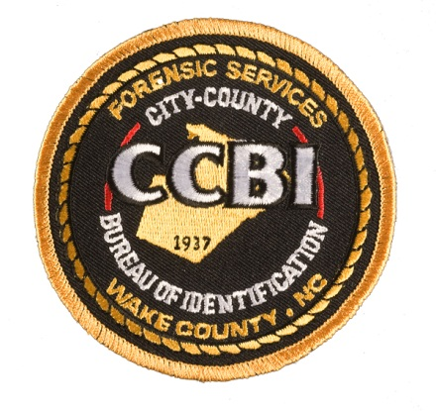

This guide may be duplicated and distributed to any
law enforcement officer whose duties include the collection,
preservation, and submission of evidence to the
Raleigh/Wake City-County Bureau of Identification
Crime Laboratory Division.

Table of Contents

SPECIAL NOTICE # 1 6
Evidence Seals 6
WHERE TO SUBMIT EVIDENCE 7
EVIDENCE CONTROL UNIT 9
Evidence Acceptance Policy 9
Evidence Submission Procedures 10
Evidence Submission Forms 10
Evidence Packaging 12
COMPUTER FORENSICS UNIT 14
Capabilities and Services 14
Case Acceptance Criteria 14
Collection of Digital Evidence 14
Digital Evidence Packaging 15
Digital Evidence Submission Requirements 16
Items permissible for submission include: 17
Do NOT Submit: 17
DRUG CHEMISTRY UNIT 18
Capabilities and Services 18
Evidence Submission Guidelines 18
Limitations to Evidence Submission 20
Report Interpretation 20
DWI BLOOD CHEMISTRY UNIT 21
Capabilities and Services 21
Evidence Submission Guidelines 21
Limitations to Evidence Submission 22
Report Interpretation 23
FORENSIC PHOTOGRAPHY UNIT 24
Capabilities and Services 24
Analog Video 24
Digital Video 24
Evidence Packaging 25
Return of Video Evidence 26
Limitations 26
LATENT PRINT UNIT 27
Services 27
Evidence submission guidelines 28
Latent print evidence 28
Latent footwear evidence 28
Known standards 29
Requests for Comparison of Ten Print / Latent / Footwear Evidence 32
Submitting a Request for Comparison 33
Latent Print Evidence 33
Footwear Evidence 34
Ten Print Examination 36
Latent Print and Footwear Database Searches 37
Local Latent Print Searches 38
State Latent Print Searches 38
Federal Latent Print Searches 38
Concerning All Latent Print Individual Characteristic Database Searches 39
Footwear Impression Evidence Database Searches 39
Report Interpretation 41
FACIAL RECOGNITION SEARCHING 43
Capabilities and Services 43
Case Acceptance Criteria 43
Evidence Packaging 44
Limitations 45

SPECIAL NOTICE # 1

Evidence Seals

All evidence submitted to the CCBI Crime Laboratory Division must be in a sealed condition. The only seals which will be accepted are:

• Tape
• Heat Sealed Packages

All evidence seals must be initialed, in permanent ink, by the person sealing the package or placing a seal on the package.

In the case of tape, the initials may be on the tape or partly on the tape and extending onto the package surface. But, in any case, the initials must be either on the tape or partially on the tape.

Tamper-proof packages must be additionally sealed with tape, with the initials on either the tape or partially on the tape. For heat sealed packages, the initials must be as close as practical to the seal.

Evidence which does not meet the sealing requirement cannot be accepted for analysis by the CCBI Crime Laboratory Division.

If it is not practical to package a piece of evidence, the officer or technician submitting that evidence should securely attach a tag to the evidence and initial the tag.

All evidence containers/packages must be sealed to the extent that nothing may be added to or removed from the container/package.

WHERE TO SUBMIT EVIDENCE

Raleigh/Wake Raleigh/Wake City-County Bureau of Identification
3301 Hammond Road
Raleigh, NC 27603
919-255-7335

NOTE: CCBI shares a complex with the Wake County Detention Center. The Detention Center is located at the intersection of Hammond Road and Chapanoke Road.

Enter the driveway and make a right turn to go around the parking deck. Enter the first gate (Gate 6) and pass the garage bays on the left. The Evidence Receiving Unit is located on the left before the second gate (Gate 1). The sign by the door reads “Evidence Receiving C1395.” Ring the doorbell to gain access.

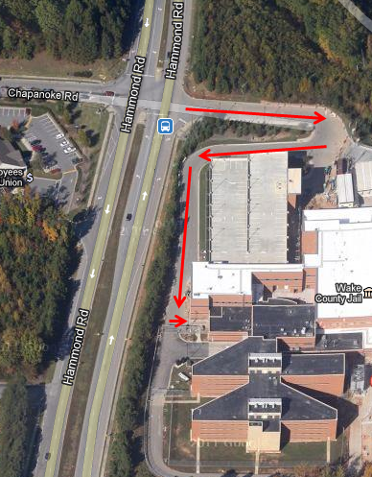

EVIDENCE CONTROL UNIT

The Evidence Control Unit ensures proper evidence flow and tracking. The Evidence Control Unit receives, distributes, and returns all evidence processed by the CCBI Crime Laboratory Division (hereinafter “Crime Laboratory”).

Forensic Evidence Custodians, and other approved personnel, receive and store all evidence submitted to the Crime Laboratory after the case information is logged into the Crime Laboratory’s RMS system. The evidence is transferred to the appropriate Crime Laboratory analyst(s) for analysis. Generally, the submitting officer will not meet directly with the analyst who will conduct the analysis. Exceptions to this practice may be made for individual cases when circumstances require the submitting officer to talk directly with the analyst(s). If you feel you have a special need to discuss certain aspects of your case, you may request such a meeting with the analyst(s).

Evidence Acceptance Policy

The CCBI Crime Laboratory Division accepts evidence which meets the following criteria:

• The evidence has been obtained as the result of an official criminal investigation in Wake County.

• The submitting agency is a federal agency with Wake County jurisdiction or a law enforcement agency or company/campus police agency certified or commissioned through the North Carolina Criminal Justice Education and Training Standards Commission, the North Carolina Sheriffs’ Education and Training Standards Commission, or the North Carolina Company and Campus Police Program.

• The investigating officer intends to pursue a criminal case pending the results of evidence analysis and/or the related investigation.

• The evidence has not been previously examined by another analyst or laboratory, unless prior approval has been requested and received from the Deputy Director for the CCBI Crime Laboratory Division and/or CCBI Director.

Evidence Submission Procedures

Adherence to proper evidence submission procedures is essential for analysts to evaluate evidence properly, to maintain the chain of custody, and to maintain the physical integrity and evidentiary value of submitted items. Failure to follow the Crime Laboratory’s instructions when submitting evidence could result in the evidence being refused for acceptance.

Evidence Submission Forms

• Attached to each CCBI Laboratory Examination Request form is an instruction sheet with numerous submission highlights. Please read the appropriate instructions entirely before completing the form.

• Fill out the CCBI Laboratory Examination Request completely, supplying all information requested. Type the form or print it legibly, ensuring that all copies are useable.

• Use a continuation page when needed. Both CCBI Laboratory Examination Requests forms and Continuation forms are available from the Evidence Control Unit or may be provided electronically upon request.

- The CCBI Forensic Computer Examination Request for Service form must be completed on all computer forensics requests. The form must indicate the legal authority by which the computer evidence was seized, and a copy of the legal documentation (search warrant, court order, etc.) must be attached to the form.

• Do not allow submission forms, packages, or other cases you may be transporting to become contaminated by biological or other potentially hazardous evidence. Keep all submission documents and other evidence away from contaminated evidence when preparing evidence for submission to the Crime Laboratory or transporting evidence to the lab. For safety reasons, stained submission documents will not be accepted by the Crime Laboratory.

• Some considerations for completing the form include:

(1) Requesting Official: Please use the same officer for all submissions in a given case.

(2) CCBI Case Number: If evidence has previously been submitted in a case, and you know the CCBI case number, please provide that number. If you do not know the specific number, please advise the Forensic Evidence Custodian that other evidence has been submitted in the case.

(3) CCBI Item # COLUMN: This column is for CCBI use only. Do not write anything in this column.

(4) Type of Exam Requested: Be as specific as possible. The Crime Laboratory will not arbitrarily examine evidence without a specific request for each discipline needed clearly requested on the “CCBI Laboratory Examination Request.” Examples include:

- Controlled substance analysis
- Digital evidence analysis
- DWI (Blood Alcohol)
- DWI-Drugs
- Forensic photography
- Latent print comparison
- Footwear comparison

(5) Exact Location Evidence Found: Give the exact location where the evidence was seized or collected, (i.e., victim (name), suspect (name), bedroom, vehicle, etc.). Note: For the safety of all who might handle the evidence, always indicate when evidence was recovered or seized from a body cavity or contaminated area or is considered a biohazard.

(6) Chain of Custody: This section is for CCBI use only. Do not record evidence transfers between non-CCBI employees in this area.

- (7) Disposition of Evidence: The Crime Laboratory is not a long term storage facility. All items must be picked up by the submitting agency as soon as possible. Failure to do so may result in refusal of all subsequent submissions until items are picked up. Packaging for DWI Blood Chemistry Unit submissions will not be retained by the Crime Laboratory, only the blood tubes will be retained. The blood tubes will be retained by the laboratory for a minimum period of 12 months after the report is published. The blood tubes will be destroyed following 12 months after the case is filed or after the case is concluded in the trial court and not under appeal, whichever is later, without further notice. However, if a Motion to Preserve the evidence has been filed by either party and is received by the Crime Laboratory, the evidence will remain in the custody of the Crime Laboratory or be returned to the submitting agency that collected the sample until dispositive order of a court of competent jurisdiction is entered and received by the Crime Laboratory.

(8) By submitting the CCBI Laboratory Examination Request form, you acknowledge and approve the Crime Laboratory personnel to select and use the most appropriate and up-to-date methods authorized by the Crime Laboratory.

Evidence Packaging

• Package and seal each item individually as appropriate for that type of evidence. See specific sections of this guide for more detailed instructions.

• Mark each item with the item number you listed on the CCBI Laboratory Examination Request form, your name or initials, and your case number.

- Packages containing biological materials or materials subjected to biological contamination as biological hazards (biohazard) shall be clearly marked. In addition, the submitting officer must indicate on the CCBI Laboratory Examination Request Form (1) that the case contains biohazardous evidence and (2) exactly where the biohazardous evidence was collected.
• Seal and package evidence with protective padding when necessary to prevent breakage, leakage, cross-contamination, or deterioration. Note: See Special Notice #1 on page 5 for detailed instructions on proper seals.

REMEMBER: All seals must be initialed (with permanent ink) by the individual sealing the evidence, and the initials must be on the tape. It is a good idea to initial the seal in such a manner that the initials extend off of the tape onto the package.

• Bring all copies of the Laboratory Examination Request Form to the Crime Laboratory. The forms will be signed showing transfer of the evidence to us, and one copy will be returned to you as a receipt. Crime Laboratory personnel will not sign another agency’s receipts.

• Weapons must be unloaded prior to submission. If the weapon is loaded due to a technical reason, advise the Forensic Evidence Custodian at 919-255-7335 prior to arrival.

• When a weapon is submitted to the Crime Laboratory, it must be visually apparent that the weapon has been made safe. This may be accomplished by any method satisfactory to the Evidence Receiving Unit but may include, for example, removing the magazine, locking the slide to the rear, and inserting a zip tie through the barrel. Because the Evidence Receiving Unit will visually inspect the weapon for safety, seals will be applied to the evidence packaging at time of submission.

Evidence Submission Checklist

• Are the Laboratory Examination Request Forms completely filled out, including any required additional forms?

• Have you indicated the type analysis needed for each item of evidence?

• Is the evidence marked and sealed? Are the seals initialed?

Change in Case Status/Information

If the status of a case or the progress of an investigation changes and there is no longer a need for the evidence to be analyzed, please advise CCBI of the change via an email to ccbievidence@wakegov.com or ccbilatentrequest@wakegov.com for Latent Print Unit cases. Knowing that the analysis is no longer needed will free valuable analysis time for other cases.

Requests to correct erroneous information after submitting the original CCBI Laboratory Examination Request Form may be made by the requesting agency via email to ccbievidence@wakegov.com or ccbilatentrequest@wakegov.com for Latent Print Unit requests. The request must refer to the erroneous information which appeared on the submitted form and specify the appropriate change(s).

Protection of Evidence from Deleterious Change

It is the responsibility of the Crime Laboratory to ensure, insofar as reasonable and possible, that evidence does not undergo deleterious change while in our possession.

However, proper collection and packaging of evidence are the responsibility of the submitting officer. One of the purposes of this Evidence Submission Guide is to make investigators aware of how to handle certain evidence to prevent deterioration prior to submission to the Crime Laboratory.

If an officer delivers evidence packaged in such a way that the evidence is in danger of deterioration, the officer may be asked to repackage the evidence prior to submission.

COMPUTER FORENSICS UNIT

The Computer Forensics Unit is responsible for the forensic examination of digital evidence.

Capabilities and Services

- Analysis of computers

- Analysis of cellular telephones and similar communication devices

- Analysis of mobile digital devices

- Analysis of digital storage media

Case Acceptance Criteria

The Crime Laboratory will accept computer forensic examination requests relating to the following incidents:

1. Crimes against children regardless of whether they are a misdemeanor or felony (e.g., child sexual exploitation, child abduction, sexual assaults against children, indecent liberties with a minor);

2. Homicide and other death investigations;

3. Felony assaults;

4. Felony drug offenses;

5. Felony financial crimes; and

6. Other felonies

Collection of Digital Evidence

Caution should be used in the collection of digital evidence due to its volatile nature.

• If the computer to be seized is “off” at the time of discovery, do not turn it on or attempt to determine what evidence may be on it. By turning on the computer, you may alter the dates, times, and files, thus changing and/or destroying evidence.

• If the computer is “on,” digitally photograph any file or files that are open at the time the computer is seized. To turn the computer off, pull the plug from the back of the computer, not the wall. If the computer is a laptop, also remove the battery.

• Any relevant computer manuals or software located at the scene shall also be collected and may be submitted to the Crime Laboratory as items of evidence at a later date if needed.

• At the time of the crime scene search, it is imperative to search, with proper legal authority, the area extensively for passwords. They may be jotted down on a desk blotter, a post-it note, or posted anywhere near the work station. Without them, data may be inaccessible.

• When seizing electronic devices such as cellular phones and PDAs, be sure to look for and seize any power cords, chargers, or cables to charge the batteries in these devices or to connect these devices to computers.

• For cell phones, if the cell phone is off at the time of seizure, leave the phone turned off. If the phone is on at the time of seizure, turn the phone off. If possible, remove the battery from the phone and submit with the phone.

Digital Evidence Packaging

- As with all evidence accepted by the Crime Laboratory, containers must be adequately sealed and initialed by the person sealing the packages.

- If a power cable or battery to a digital device has been seized, package it with the digital device.

- If any evidence has been contaminated with body fluids or other hazardous material, mark the outer packaging accordingly.

- Digital devices and storage media should be wrapped in paper, in a paper bag, or in a paper box to protect against static electricity. If possible, optical media such as DVDs and CDs should be placed in sleeves or cases to protect against damage while in evidence.

- If a digital device is packaged in a box, do not pack the item in Styrofoam peanuts or shredded paper.

- If the digital device cannot be wrapped in paper, packaging or evidence tape should be placed across each drive slot in such a way that media can neither be removed nor added without breaking the tape. Also place tape across the power cable receptacle on the device. Finally, place tape across the item’s case in such a way that it cannot be opened without breaking the tape.

- Remove the battery from cellular phones and package the battery with the cellular phone.

- If a cellular phone or other mobile device has been left on, it must be shielded from cellular signals and radio signals. The preference is to seal the device in a clean arson can. If one is not available, an alternative is to wrap the device tightly in several layers of heavy duty aluminum foil.

- Do not use a ballpoint or gel pen when marking removable storage media as damage to data can occur. Use felt markers only (such as Sharpies).
- Computer media should be packaged separately in evidence envelopes or bags and identified with sequential item numbers that represent an accurate inventory of the items being submitted. For example:

Item #1: Box containing one Digital PC 5000 tower computer.
Item #2: Paper bag containing five (5) floppy disks and one (1) CD.
Item #3: Paper bag containing one (1) Nokia cellular phone.

Digital Evidence Submission Requirements

Fill out the CCBI Laboratory Examination Request Form, supplying all information requested.

Complete the CCBI Forensic Computer Examination Request for Service Form. All computer forensic submissions must be accompanied by this form. Be sure to answer the questions in depth in order for the examiner to understand the request and provide a productive file search. A copy of the legal authority for the search and seizure (e.g. court order, search warrant, written consent to search) must be attached to the CCBI Forensic Computer Examination Request for Service Form.

Items permissible for submission include:

• Computers (towers, desktops, laptops, tablets)

• Mobile devices (mp3 players, GPS units, digital voice recorders, eReaders)

• Digital still cameras and digital video cameras (including storage media)

• Cellular telephones, pagers, and PDAs

• Digital storage media (hard disks, optical discs, floppy disks, flash media, USB drives, etc.)

• Any passwords, user ID’s, or screen names

Do NOT Submit:

• Computer displays/monitors

• Keyboard, mouse, or other accessories

• Printers, scanners, USB hubs, speakers

DRUG CHEMISTRY UNIT

Capabilities and Services

Analysis to determine the presence of controlled substances.

Evidence Submission Guidelines

The Drug Chemistry Unit accepts evidence for analysis in cases where an arrest has been made or is anticipated. Evidence that has no value for criminal prosecution will not be accepted. The submission form should include the name of an individual who has been charged with a criminal offense or will be charged with a criminal offense based upon the results of the analysis.
- Do not submit any marijuana cases for analysis involving less than 112 grams unless a sale or delivery is charged or requested by the District Attorney’s Office.

- Do not submit any cocaine cases for analysis involving less than 1 gram unless a sale or delivery is charged or requested by the District Attorney’s Office.

- Prior to submission, separate suspected controlled substances from containers to be processed for latent prints. Take care to maintain the integrity of each packaging unit, i.e., don’t combine material from individual packages.

- Separate and individually seal items to prevent cross-contamination.

- Submit drug evidence seized from different people on the same occasion on separate CCBI Laboratory Examination Request Forms.

- If multiple people are to be charged with the same evidence, submit the drug evidence on a single CCBI Laboratory Examination Request Form.

- Submit drug evidence seized from the same person on different occasions on separate CCBI Laboratory Examination Request Forms.

- Submit all of the evidence in a case at the same time, when possible.

- Do not submit paraphernalia which is not suspected to contain controlled substances.

- Do not submit used field test kits. Do not apply field test kits directly to evidence to be submitted as it will render the material unsuitable for analysis. Do not field test residues or small amounts of material as it may prevent the Crime Laboratory from having sufficient material for analysis.

- Include all relevant information on the CCBI Laboratory Examination Request Form to ensure that the best evidence is analyzed. It is not practicable for the Crime Laboratory to analyze every item in every submission. Submissions containing multiple items and/or multiple types of material in a single item will be evaluated and the best evidence analyzed.

- When pipes, spoons, straws, razors, scales, or other items suspected to contain a residue amount of controlled substance are to be submitted, place them in the smallest container possible. Do not add tape directly to the items. Add any outer packaging necessary to prevent breakage, negate sharp hazards, and facilitate handling.

- Hypodermic needles are not routinely accepted for analysis. Such analysis must be requested in writing by the Wake County District Attorney’s Office. If possible, remove the suspected controlled substance from the syringe prior to submission.

- Mark packages containing biological materials or materials subjected to biological contamination as biological hazards (biohazard). In addition, the submitting officer must indicate on the CCBI Laboratory Examination Request Form (1) that the case contains bio-hazardous evidence and (2) exactly where the bio-hazardous evidence was collected.

- Dry plant material, including mushrooms and cacti, thoroughly prior to submission. Submit plant material in paper bags. Fresh plant material and plant material not thoroughly dried will decompose when stored in plastic bags, destroying the evidentiary value.

- A representative sample of plants should be submitted rather than the entire plant when no additional charges or enhancements can be obtained based upon the weight of the plant.

- Do not submit drug evidence directly associated with a death investigation. The Office of the Chief Medical Examiner performs death investigations. Exceptions must be approved by the Deputy Director of the CCBI Crime Laboratory Division.

Limitations to Evidence Submission

- The Drug Chemistry Unit generally will not analyze more than two (2) items from the same schedule or suspected schedule of the Controlled Substances Act for each subject or group of subjects unless the analysis of additional items will shift the charge from a misdemeanor to a felony or to a trafficking charge. Misdemeanor items generally will not be analyzed in felony cases.

- The Drug Chemistry Unit does not analyze evidence in poisoning cases unless the evidence is suspected to be a controlled substance. The laboratory does not analyze for substances other than controlled substances.

- The Drug Chemistry Unit will not analyze for controlled substance residues on US currency or in stomach contents (lavage). Bags or other units suspected to contain controlled substances which have been removed from stomach contents may be submitted.

Report Interpretation

- Drug Chemistry Unit laboratory reports list the controlled substances that an item was found to contain. The Drug Chemistry Unit does not determine purity or the concentration of a particular substance.

- Weights reported on a Drug Chemistry Unit laboratory report are designated as a “net” or “gross” weight. A “net” weight is the weight of the submitted material without any packaging present. A “gross” weight is the weight of the submitted material and packaging.

- Salt forms of a controlled substance are not typically included on a Drug Chemistry Unit laboratory report except for cocaine submissions. When the salt form of cocaine is determined, it will be designated on the laboratory report. NOTE: “Bath salts” are not considered a salt form of a controlled substance.

- When the amount of material submitted is not sufficient to complete an analysis, the result will be designated on the report as “Insufficient material for analysis.”

- When the material submitted is an amount that cannot be readily removed from the container in which it was submitted, it is designated on the report as “Residue Amount.”

DWI BLOOD CHEMISTRY UNIT

Capabilities and Services

Analysis of blood in DWI cases to determine alcohol concentration.

Analysis of blood in DWI cases to determine the presence of controlled substances and metabolites.

Analysis of blood in DWI cases to determine the presence of non-controlled substances and metabolites.

Evidence Submission Guidelines

The DWI Blood Chemistry Unit accepts evidence for analysis in cases where an arrest has been made or is anticipated. Evidence that has no value for criminal prosecution will not be accepted. The submission form must include the name of an individual who has been charged with DWI or a related offense or who will be charged with DWI or a related offense based upon the results of the analysis.
- Postmortem evidence will not be accepted by the DWI Blood Chemistry Unit. The Office of the Chief Medical Examiner performs postmortem investigations.

- Submit all blood in commercially available kits such as Vacutainer or Venoject. CCBI does not provide these kits. Use only tubes which contain a preservative and an anticoagulant (typically a gray stoppered tube). Do not submit the needle or any other unnecessary kit items other than the blood tubes.

- Collect a total of 20 ml of blood in two (2) 10 ml test tubes from the subject as soon as possible after the incident in question. If the full amount of blood cannot be collected, collect as much blood as possible. Ensure that the manufacturer’s instructions are followed regarding the mixing of the blood with the preservative and anticoagulant after collection. The instructions typically call for slow and complete inversion five times without shaking.

- Blood samples should be protected from heat; storage in a refrigerator is recommended.

- Include all relevant information on the CCBI Laboratory Examination Request including death or serious injury to a victim and suspected impairing substances. List all suspected impairing substances. Do not submit evidence in which the impairing substance is suspected to be an inhalant or GHB.

- Do not submit dried blood samples or serum.

- Do not submit blood from different subjects on the same CCBI Laboratory Examination Request Form.

- Packaging for DWI Blood Chemistry Unit submissions will not be retained by the Crime Laboratory, only the blood tubes will be retained. The blood tubes will be retained by the laboratory for a minimum period of 12 months after the report is published. The blood tubes will be destroyed following 12 months after the case is filed or after the case is concluded in the trial court and not under appeal, whichever is later, without further notice. However, if a Motion to Preserve the evidence has been filed by either party and is received by the Crime Laboratory, the evidence will remain in the custody of the Crime Laboratory or be returned to the submitting agency that collected the sample until dispositive order of a court of competent jurisdiction is entered and received by the Crime Laboratory.

Limitations to Evidence Submission

- The DWI Blood Chemistry Unit performs analyses of blood in DWI cases for alcohol concentration and the presence of controlled substances and metabolites. Analysis for the presence of non-controlled substances and metabolites will not be performed unless the analysis is requested by the Wake County District Attorney’s Office.

- The DWI Blood Chemistry Unit will not analyze blood for controlled substances when the blood has an alcohol content greater than 0.08 gram of alcohol per 100 milliliters of whole blood except in cases involving death or serious injury to a victim unless the analysis is requested by the Wake County District Attorney’s Office.

- Cases in which the preliminary drug test produces a positive indication for cannabinoids will not be subjected to confirmatory analysis for cannabinoids if other controlled substances are identified unless the confirmatory analysis is requested by the Wake County District Attorney’s Office.

- The DWI Blood Chemistry Unit does not analyze for inhalants or GHB.

- The DWI Blood Chemistry Unit does not analyze postmortem evidence.

Report Interpretation

- The blood alcohol concentration is reported as grams of alcohol per 100 milliliters of whole blood. Hospitals typically use blood serum, not whole blood, which results in a higher concentration value.

- When an analysis for the presence of controlled substances is performed, the laboratory report will state that the analysis is for controlled substances and list the controlled substances identified. When an analysis for the presence of non-controlled substances is performed, the laboratory report will state that the analysis is for non-controlled substances and list the non-controlled substances identified. The DWI Blood Chemistry Unit does not report the concentrations of identified substances in a blood drug analysis. When analysis for a specific substance is requested, and that substance generally cannot be detected by the DWI Blood Chemistry Unit methods, the report will state that the substance generally cannot be detected.

- Cases in which the preliminary drug test produces a positive indication for cannabinoids that are not subjected to confirmatory analysis for cannabinoids will be designated on the report as such.

- Cases in which the amount of blood present was not sufficient to complete an analysis will be designated as “Insufficient sample for analysis.”

FORENSIC PHOTOGRAPHY UNIT

Capabilities and Services

- Images on videos may be captured and converted to still photographs.

On the CCBI Request for Laboratory Examination form, indicate in some manner the area of the video in which you are interested. This may be indicated by listing a time frame; the time in hours, minutes, and seconds; or by describing the person you are interested in viewing. Also include any additional information that you have about the events captured in the video evidence.

Analog Video

When locating an area of interest, avoid pausing or overplaying analog video. Excessive playing and pausing of the analog video (i.e. VHS tapes, VHS-C tapes, 8mm tapes) may cause serious degradation of the video quality.

For analog tapes, the write-protection tabs should be removed before viewing the video in order to prevent accidental erasure of the evidence.

When submitting 8mm video tape, include a video camera capable of playing an 8mm video tape and all the cords, cables, power supplies, and manuals associated with that video camera.

Digital Video

For cases involving digital video (videos recovered from a DVR system), the original video files as they are stored on the system should be recovered from the DVR system to get the best quality video.

To get the best results possible, be sure that when exporting the video from the DVR system for processing, that video is exported with NO compression. Many DVR systems store video in a proprietary format.

When exporting video from the DVR system, download the proprietary video player with the video if at all possible. Write protect the media containing the exported video and video player if possible.

When submitting a DVR or other such equipment, include all the cords, cables, power supplies, and manuals associated with that equipment.

Evidence Packaging

When submitting video evidence, carefully package it to prevent damage.

- As with all evidence accepted by the CCBI Crime Laboratory, containers must be adequately sealed and initialed by the person sealing the packages.

- If a power cable, battery, or other cable(s) to a device has been seized, package them with the device.

- If any evidence has been contaminated with body fluids or other hazardous material, mark the outer packaging accordingly.

- Devices and storage media should be wrapped in paper, in a paper bag, or in a paper box to protect against static electricity. If possible, optical media such as DVDs and CDs should be placed in sleeves or cases to protect against damage while in evidence.

- If a device is packaged in a box, do not pack the item in Styrofoam peanuts or shredded paper.

- If the device cannot be wrapped in paper, packaging or evidence tape should be placed across each drive slot in such a way that media can neither be removed nor added without breaking the tape. Also place tape across the power cable receptacle on the device. Finally, place tape across the item’s case in such a way that it cannot be opened without breaking the tape.

- Do not use a ballpoint or gel pen when marking removable storage media as damage to data can occur. Use felt markers only (such as Sharpies).
- Media should be packaged separately in evidence envelopes or bags and identified with sequential item numbers that represent an accurate inventory of the items being submitted. For example:

Item #1: Box containing one (1) Sony HandyCam digital video camera.
Item #2: Paper bag containing five (5) VHS cassettes and one (1) CD.
Item #3: Paper bag containing one (1) Samsung DVR.

Return of Video Evidence

Typically, results will be returned as a CD or DVD containing the still images of interest. Please note on the CCBI Request for Laboratory Examination Form if you wish to receive the results in additional formats (ex. DVD- video, QuickTime files, 8x10 prints).

Limitations

Success in video processing is largely dependent on the quality of the surveillance video, camera placement, and the lighting of the surrounding area. Video that is captured out of focus or in shadows will limit the quality of results.

LATENT PRINT UNIT

Services

The latent print unit provides services and assistance in the analysis of any items of evidence which falls into one or more the following categories:
- Latent fingerprints
- Latent palmprints
- Latent footprints (bare feet)
- Footwear impressions
- Ten print examinations
Although the term “latent” refers to hidden or invisible impressions, the latent print unit also accepts and analyzes “patent” (visible) impressions. Please note that throughout the following guidelines, “latent” refers to both visible and invisible impressions.

Latent fingerprints, palm prints, and footprints may be of sufficient value for positive identification purposes. Such evidence may indicate that a subject’s finger, palm, or foot did make the impression in question.

On much the same premise as fingerprint identification, footwear examination results are judged on a track’s uniqueness, individuality, and class characteristics. Positive identifications may be made in footwear and may also indicate that a specific shoe did make the impression in question.

The latent print unit also provides assistance with ten print examinations, and the identification of unknown deceased individuals.

Additionally, the latent print unit conducts database searching of latent friction ridge impressions, as well as questioned footwear impressions collected from crime scenes.

Evidence submission guidelines

Latent print evidence

Latent finger/palm/feet prints

If latent print evidence (fingers, palms, bare foot) impressions collected by a non-CCBI employee are to be submitted to the latent print unit for analysis, please keep in mind the following:

  - Each lift card must contain: the date, collecting person’s initials, case number, lift card numbering, a description indicating from where the latent print was collected, and a rough sketch demonstrating the location of the print on the item processed.

  - If the collector did not wear gloves, be sure to mark an “x” over any prints left on the tape by the person collecting the prints.

  - The latent print envelope should indicate the case information, as well as the total number of lift cards contained within the envelope.

  - The envelope must be sealed in accordance with the sealing instructions provided above.

  - The envelope must be accompanied by a CCBI Laboratory Examination Request form.

  - Latent fingerprint evidence will not be returned to the contributing agency but will be securely maintained by CCBI.

Latent footwear evidence

If latent footwear evidence is being submitted to CCBI for footwear comparison against known shoes or database search through SICAR (Shoeprint Image Capture and Retrieval), the latent footwear items must be accompanied by a CCBI Laboratory Examination Request form. Upon completion of the request, the evidence items will be returned to the contributing agency.

Known standards

Finger/palm print cards

10-print cards (finger and palm prints) being submitted to the latent print unit for comparison must be received by CCBI as evidence items via the evidence intake area. As per evidence procedures, the items must be in sealed packages and the seals must be initialed. Further, the items must be accompanied by a CCBI Laboratory Examination Request form. Upon completion of the comparison, the items will be returned to the contributing agency.
If one set of known standards is going to be requested for comparison against multiple cases, the following policy is applicable: the known standards should be submitted for comparison in one of the cases. Every additional case requires its own request form, with pertinent case information listed, and in the “additional comments” section at the bottom of the form should be information directing the latent examiner to utilize the known standards which were submitted under the first case number.
When the known standards are submitted for comparison as part of a court order, a complete set of copies of all court order paperwork must be attached to the request. Please be aware that if the case information listed on the request form does not correspond exactly with the case information listed on the court order paperwork the latent unit cannot compare the case.

Example: Request for Comparison with 10-print cards submitted as evidence items.
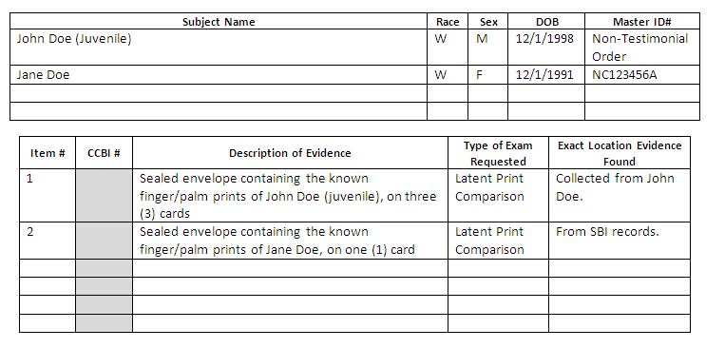

Known feet prints

In the event that known foot prints (bare feet impressions) are needed for comparison, they can be collected by a CCBI employee (either a Crime Scene Investigator or a Latent Print Examiner) as long as all legal requirements for this collection are satisfied. The known foot prints will be collected as an evidence item, and will be turned over to the contributing agency unless a request for comparison is received on a CCBI Laboratory Examination Request form. Should a request be received, the comparison will be conducted, and upon its completion the evidence items will be returned to the contributing agency.

Example: Request for Comparison for Foot Prints
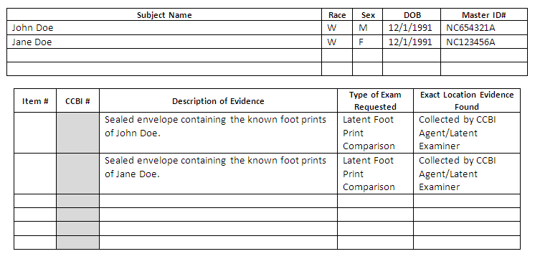

Known shoes

Known shoes may be turned over to the latent print unit for the purpose of comparison against footwear impressions collected from crime scenes. In this instance, the CCBI Laboratory Examination Request form must be completed and submitted with the evidence items.

Example: Request for Footwear Comparison
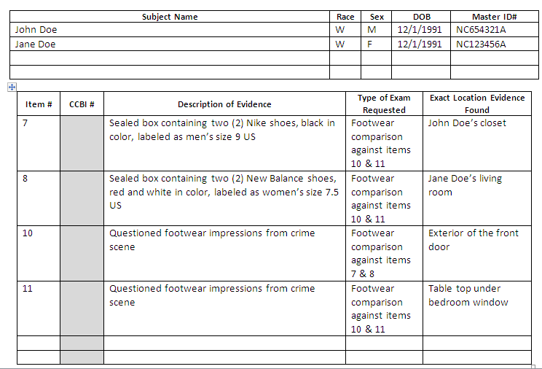

Requests for Comparison of Ten Print / Latent / Footwear Evidence

All requests for comparisons of latent print, ten print examinations, or footwear evidence must be submitted on the CCBI Laboratory Examination Request form. An additional form is required for ten print examinations, depending on the type of request (habitual felon or firearm by felon). A notation at the bottom of the request may be added to advise the examiner of the additional form associated with this request.

A comparison is conducted by a latent print examiner, at the request of an investigating authority, for the examination of specific known subject prints or known shoes against the latent impression evidence collected from crime scenes.

Submitting a Request for Comparison

There are two methods for submitting a Request for Comparison to the Latent Print Unit.

  - If any evidence item is going to accompany the Request for Comparison, it must be received via the CCBI Evidence Receiving Unit.

  - If the Request for Comparison does not include accompanying evidence items, the request must be forwarded to the CCBI Latent Print Unit via email at: ccbilatentrequest@wakegov.com. An email indicating the confirmation of receipt will be sent to the requestor. If a confirmation message is not received by the requestor after a few days of submitting a request to the Latent Print Unit, please contact the Latent Print Unit to ensure that the request was received.

Latent Print Evidence

For requests for comparison of latent print evidence, indicate the names of the subjects to be compared in the area noted as “Subject Name”. Please note that if the subjects listed do not have arrests in Wake County for which known finger and palm prints are on file at CCBI, no latent print comparison can be performed. In this instance, it falls upon the requesting individual to locate a copy of the known finger/palm print card from another jurisdiction and submit it to CCBI as an evidence item (see Section 2, Part B). In the area listed as “Master ID”, reference the North Carolina State Identification number (SID number) or the Wake County identification number for each individual being requested for comparison. In the area listed as “Type of Exam Requested”, reference “latent print comparison”.

Example: 4: 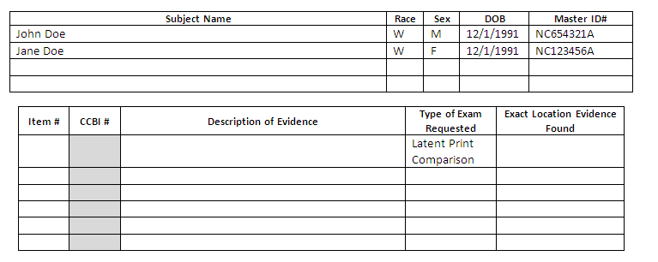

Footwear Evidence

For requests for comparison of footwear impression evidence, indicate which item numbers are being requested for comparison against other item numbers.
The CCBI Laboratory Examination Request form for footwear requests is submitted at the same time that the questioned and/or known shoes are turned over to CCBI for comparison. The evidence items and request form should be turned over at the CCBI Evidence Receiving Unit.

Example: Request for Footwear Comparison
Upon completion of the examination by the latent examiner, the reporting system will be updated with results, and all evidence items will be returned to the contributing agency.

Ten Print Examination

A request for a ten print examination must be received on the CCBI Laboratory Examination Request form. However, because this form does not contain all the fields for information specific to ten print examinations, a supplemental request form is necessary. Please utilize either the Habitual Felon request form or the Firearm by Felon request form, whichever is applicable to the request.
Example: Request for Ten Print Examination
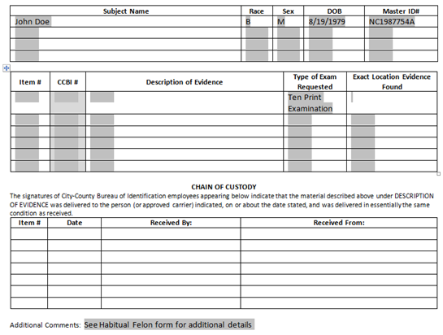

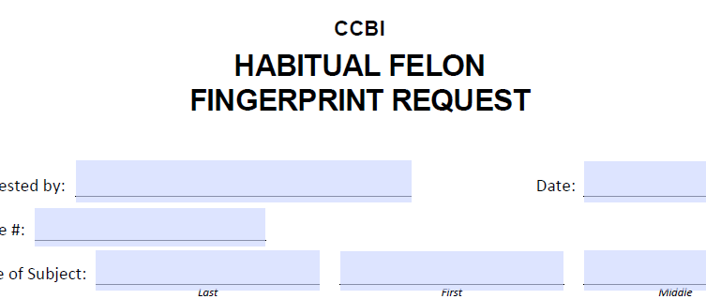

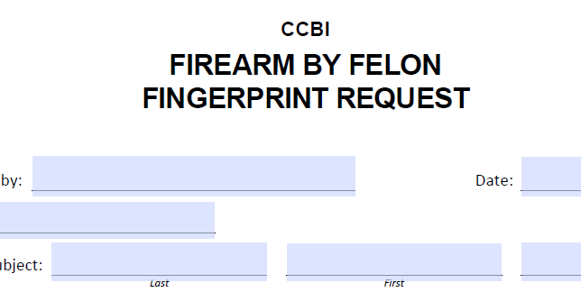

Latent Print and Footwear Database Searches

The latent print unit will automatically database search latent finger and palm print evidence collected from crime scenes, if the latent print evidence is of sufficient value to be searched. Latent print evidence from person crimes cases is typically given first priority for database searching. Residential and commercial burglaries are typically given second priority for database searching. Other property crimes (larceny from auto, damage to property, etc.) are assigned to a lower priority, and depending on the number of higher priority cases being searched, may be stored for database searching at a later time.

The latent print unit will also review footwear impression evidence collected from crime scenes, and at the written request of an investigator, search the images through a footwear database.

Local Latent Print Searches

The local database system, known as SPEX, is an individual characteristic database that allows for the searching of unknown latent finger and palm print evidence against known finger and palm print standards maintained on record in Wake County. SPEX is currently networked with various other agencies throughout North Carolina and shares known finger and palm print records with those agencies.

State Latent Print Searches

The latent print unit has access to the North Carolina State Automated Fingerprint Identification System (SAFIS). The SAFIS stores images of most of the fingerprint cards on file at the State Bureau of Investigation.

The SAFIS is able to search latent finger and palm print evidence from crime scenes against criminal finger and palm print cards stored in the state system.

Federal Latent Print Searches

The latent print unit also has access to the FBI Integrated Automated Fingerprint Identification System (IAFIS). The IAFIS stores most of the criminal fingerprint records maintained by the Federal Bureau of Investigation.

The IAFIS allows for latent fingerprints to be searched nationally. If a person has a criminal record in another state, the latent print unit may be able to effect an identification to that individual.

Please be aware that neither SAFIS nor IAFIS have the capability of searching the finger joints, sides of fingers, or the tips of fingers.

Concerning All Latent Print Individual Characteristic Database Searches

None of the three above-mentioned databases is capable of searching foot print impressions (from bare feet).

The reporting system will be updated with notifications indicating which latent print lift cards contained latent print evidence that was submitted for search in any particular database.

The SPEX and SAFIS database search results will display the lift card number and will advise if latent prints were searched, and the dates those searches were conducted. The results will not indicate a positive or negative search result, since once the prints are entered into these systems they may be reverse-searched and a positive result may occur after a significant amount of time from the initial entry.

The IAFIS database search results will display the lift card number, if the result was negative, and the date the search was conducted.

For each system, if a search result is positive, a latent print report will be produced.

Do not assume that a crime was committed by someone who does not have a prior record simply because the database searches did not yield a positive result. Not all criminal fingerprint cards are loaded in to the databases, and depending on the quality of the fingerprint card entered into the systems, it may be impossible to match a particular individual’s fingerprints with those left at a crime scene.

Footwear Impression Evidence Database Searches

The latent print unit has the ability to search footwear impressions collected from a crime scene through the Shoeprint Image Capture and Retrieval system (SICAR). This database allows for the searching of questioned footwear impressions and may provide the possible manufacturer of those unknown footwear impressions. It is important to note that this system is not an identification system; it does not indicate if a certain footwear impression from a crime scene was made by the known shoe from a person. Instead, its database contains thousands of known footwear samples, and SICAR may potentially provide a type of shoe that could have made the unknown impressions.

Footwear Evidence Collected from Crime Scenes:

Footwear impression evidence collected from crime scenes is not automatically forwarded to the latent print unit. Rather, it is sent directly to the contributing agency by the Crime Scene Investigators. Therefore, should an investigator desire a SICAR search of footwear impression evidence, the evidence items and a request for SICAR search on a CCBI Laboratory Examination Request form, must be received. See example below.

Upon the completion of the SICAR search, a SICAR report will be generated and the evidence items will be returned to the contributing agency.

Any specific questions concerning SICAR should be directed to the latent print unit.

Example: Request for SICAR Footwear Database Search on Questioned Footwear Impressions
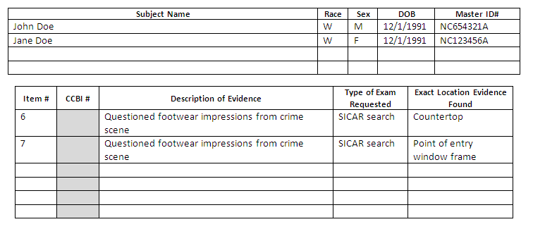

Report Interpretation

A latent print report lists the results of the latent print comparative analysis.
Identification may be effected should the subject’s inked/known impressions of the corresponding area be available for comparison.

The conclusions that may be drawn as a result of a latent print comparison are as follows:
- A latent print identification was effected to a specific individual.
- The subject compared was excluded as the source of the latent print impression.
- Inconclusive results due to low quality known standards, or lacking of a specific area of the known standards, low quality latent (subject cannot be excluded as the source of origin).
- The latent print evidence was not of sufficient value for comparison and/or identification purposes.
The conclusions that may be drawn as a result of a ten print examination are:
- The fingerprint or fingerprints were made by the same source and therefore came from the same person.
- The fingerprint or fingerprints were not made by the same source and therefore did not come from the same person.
Footwear reports lists the items submitted and the results of the comparative analysis. Some of the conclusions that may be drawn by comparing the footwear evidence are listed below:
- The questioned footwear impression was identified as having been made by the left/right known shoe.
- The questioned footwear impression was of a different outsole design and was not made by the known shoes.
- The questioned footwear impression corresponds in outsole design, physical size, and general wear with the known right/left shoes and could have been made by that shoe or any other right/left shoe having the same outsole design, physical size, and general wear.
- The questioned footwear impression was insufficient for comparison purposes.
If you have questions about the results, please contact the latent print unit.

The latent print unit attempts to return evidence as soon as the examination is complete and a report has been published.

FACIAL RECOGNITION SEARCHING

Capabilities and Services

This service allows the law enforcement community to submit photos and/or videos of unknown individuals to the CCBI for facial recognition searching (FR) and comparison purposes.

Evidence Submission Guidelines
A variety of images and videos can be submitted for Facial Recognition searches and comparison.

Case Acceptance Criteria

The Crime Laboratory will accept facial recognition comparison requests for cases that have occurred on May 1, 2015 and forward. Historic cases will only be accepted with the prior approval of the Deputy Director of the Crime Laboratory or the CCBI Director.

A CCBI Laboratory Request Form is required for all submissions for Facial Recognition services.

For video submissions, a CCBI Facial Recognition Supplemental Submission Form is also required.

All images and videos will be submitted to CCBI digitally via a secure URL. Contact the CCBI Facial Recognition Examiner at 919-255-7354 for the URL address and the user name and password. The CCBI Laboratory Request Form and the CCBI Facial Recognition Supplemental Submission Form are available through the URL and will be submitted along with the images and/or videos.

All images submitted for Facial Recognition should consist of the original images in the highest quality format available.

For cases involving digital video, the native video files should be downloaded from the surveillance system with NO compression along with their video players and/or codecs in order to retrieve the best video quality possible. The appropriate video players or codecs are to be submitted along with the video.

Indicate on the FR Supplemental Submissions Form the portion of the video that is of interest. This may be indicated by listing a time frame or the time in hours, minutes, and seconds (time stamp on the video itself). Indicate the subject of interest by describing that person including a physical description and any actions that subject is taking in the video. Also include any additional information that you have about the events captured in the video evidence. If there are multiple subjects of interest, indicate the number of subjects, the portion of the video for each subject, and a description for each subject.

Any deviation from these submission guidelines must have prior approval from the Deputy Director of the Crime Laboratory or the CCBI Director and may be subject to standard evidence submission guidelines.

Limitations

Success in Facial Recognition is largely dependent on the quality of the submitted image(s) and/or video(s) which includes camera placement, lighting, and pose/expression of the subject.

Revision History
Effective Date | Version Number | Reason
1/1/13 | 1 | Policy compliance with ISO 17025
7/14/14 | 2 | Inclusion of Ten Print Examination and updates from annual review
6/4/15 | 3 | Inclusion of facial recognition services
8/31/2015 | 4 | Update wording for DWI Blood Chemistry Unit regarding non-controlled susbstances
11/28/16 | 5 | Update submission guidelines for Facial Recognition

